Sheet 1

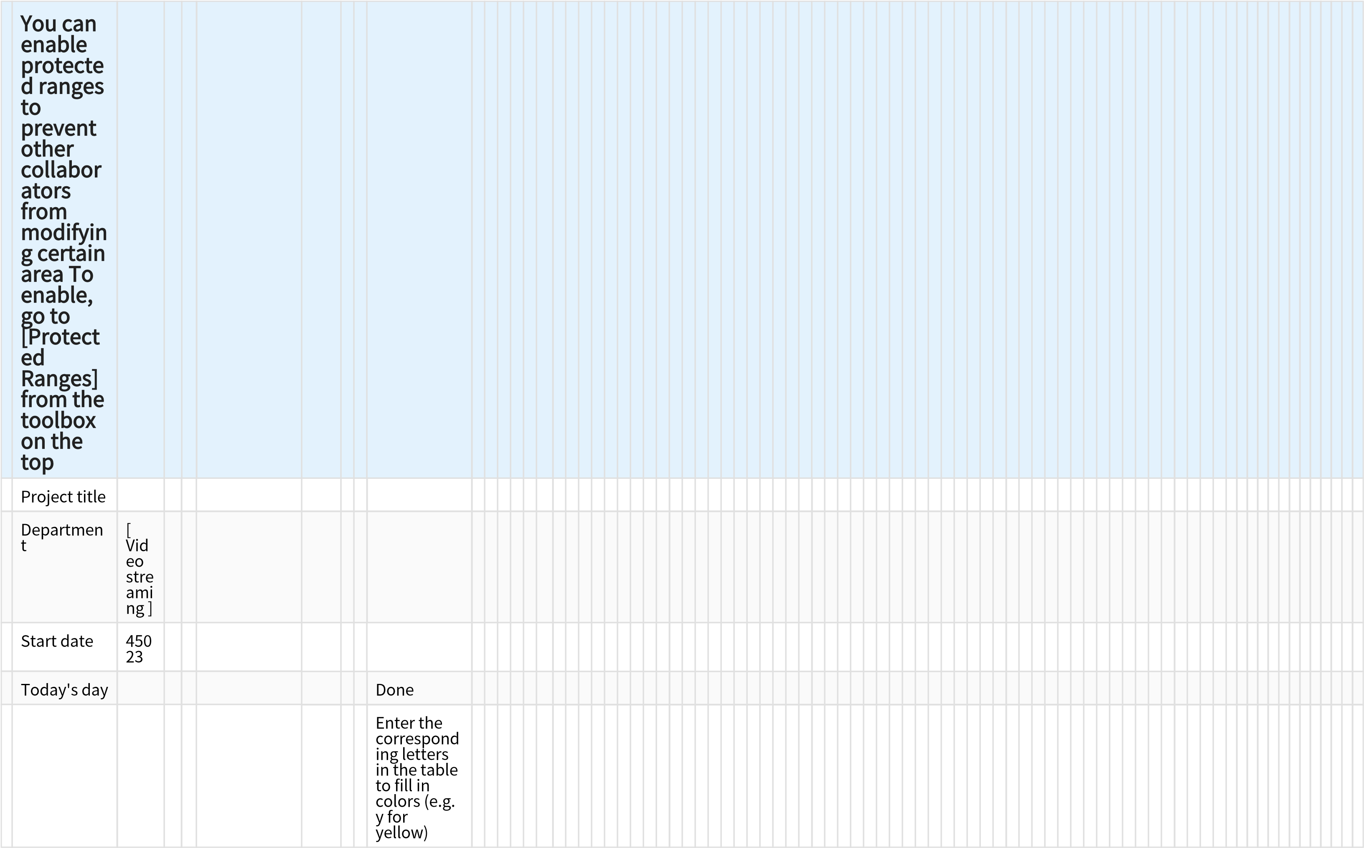
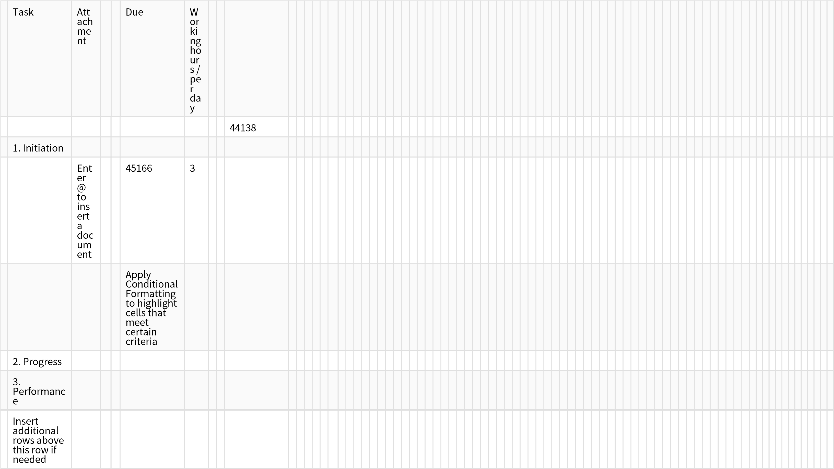
Sheet 2

 | Owner | Working hours / per day |  | Step1：use SUMIF to sum total hours for everyone
1.Initiation |  |  |  | Name | Working hours / person per day
1
2
3
4
2.Progress
1
2 |  |  |  | Step2: use graph to see a visual display
3
4
5
3.Performance
1
2
3
4
5

